# Supplementary information

# A potential use of ego-centric co-authorship network analysis for inspecting research misconduct: A case study of Thai researchers

Phrutsamon Wongnak1, Tanaphum Wichaita1, Anuwat Wiratsudakul2,3, Wirichada Pan-ngum1,4*

Table S1 Abbreviations for authorship profiles used throughout the article

|  |  |
| --- | --- |
| **Variable** | **Abbreviation** |
| Time since first article (years) | t_since_y1 |
| Average article number in the past 5 years | avg_pubNo_5y |
| Maximum article number in the past 5 years | max_pubNo_5y |
| Proportion of review/systematic review/meta-analysis articles | prop_review |
| Number of communities | n_community |
| Clustering coefficient | clustering_coef |
| Diversity of research domains | domain_diversity |
| Proportion of co-authors from Southern Asia | prop_south_asia |
| Proportion of co-authors from Western Asia | prop_west_asia |
| Proportion of co-authors from Eastern Europe | prop_eastern_europe |
| Proportion of co-authors from Thailand | prop_thailand |
| Proportion of co-authors from non-Thailand Southeastern Asia | prop_southeast_asia |

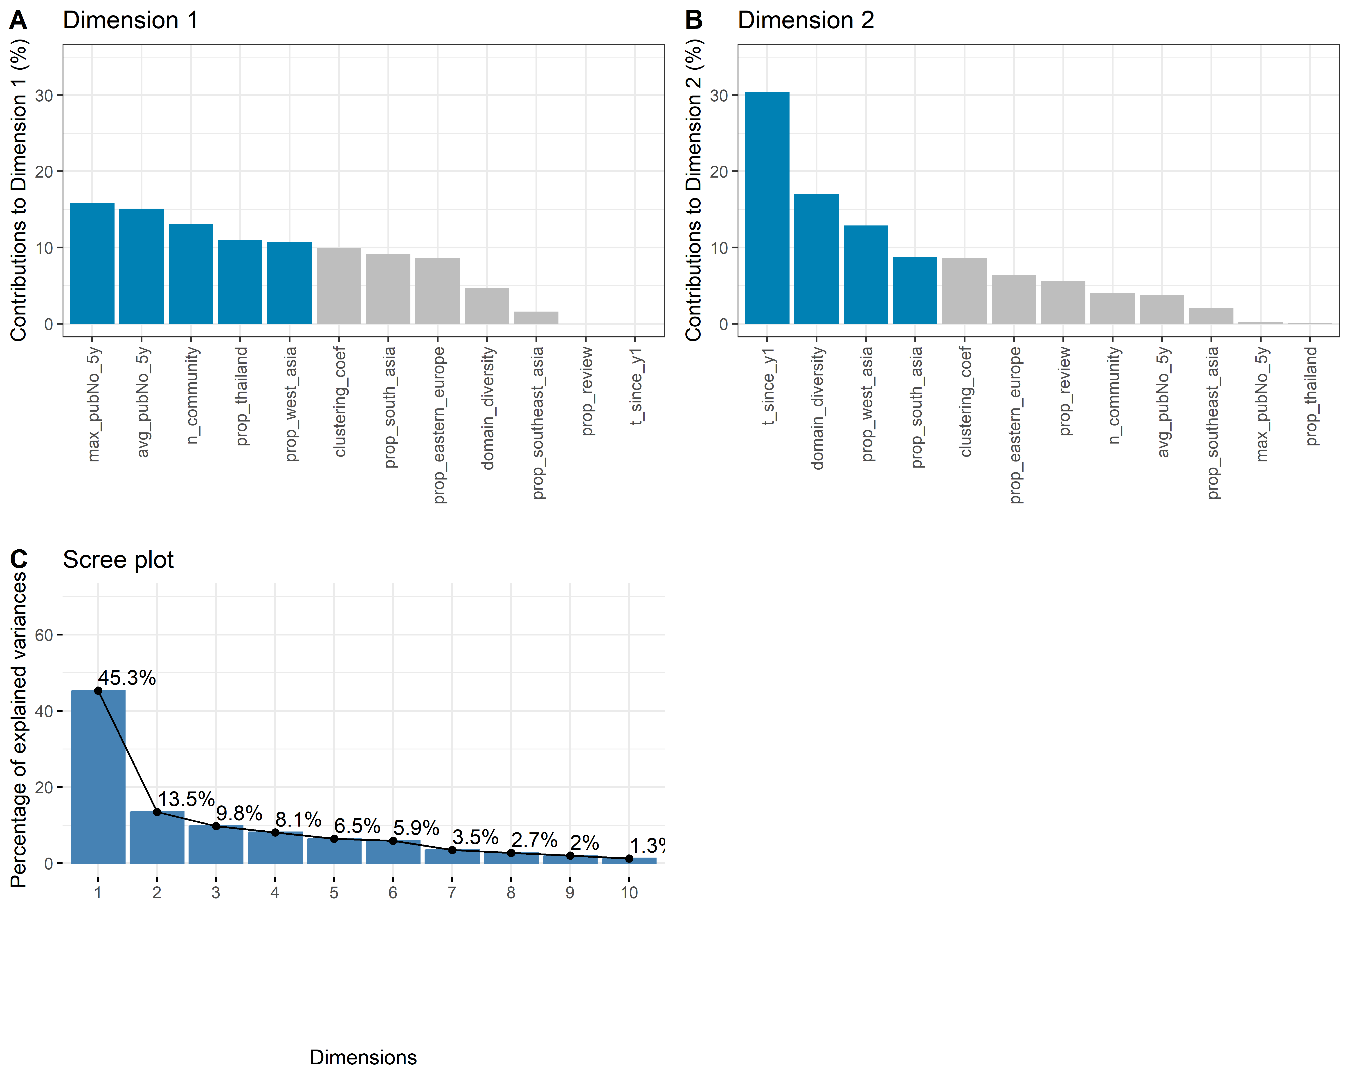

Figure S1 Contributions of ego characteristics (time since the first publication, average annual publication number during the past 5 years, research area diversity, and proportion of review/systematic review articles), alter characteristics (diversity of sub-regions of co-authors’ affiliations), and co-authorship network characteristics (network size, edge density, number of communities, and clustering coefficient) on the principal component analysis (PCA) Dimension 1 (A) and Dimension 2 (B), and the PCA scree plot (C).

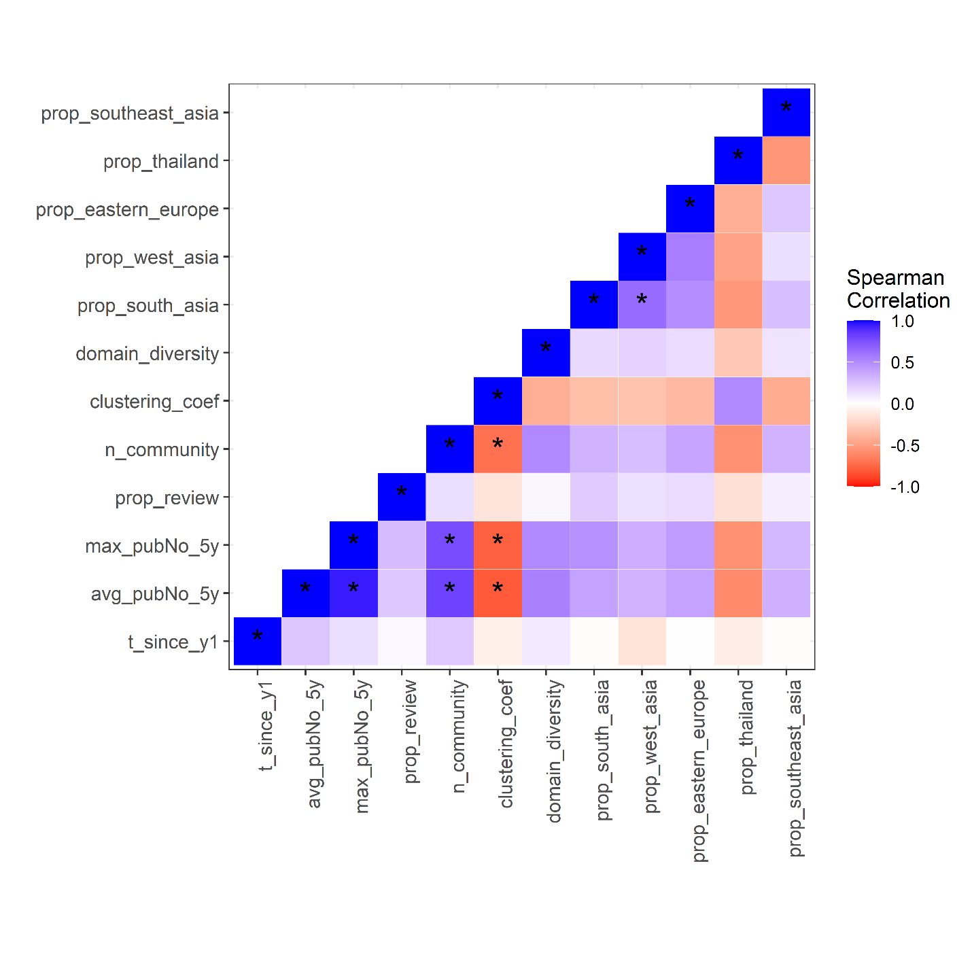

Figure S2 Pairwise Spearman’s correlation coefficient of ego characteristics (time since the first publication, average annual publication number during the past 5 years, research area diversity, and proportion of review/systematic review articles), alter characteristics (diversity of sub-regions of co-authors’ affiliations), and co-authorship network characteristics (network size, edge density, number of communities, and clustering coefficient). Colors indicate values of correlation coefficient (blue: = 1; white: = 0; red: = -1), with asterisks indicate > 0.6.

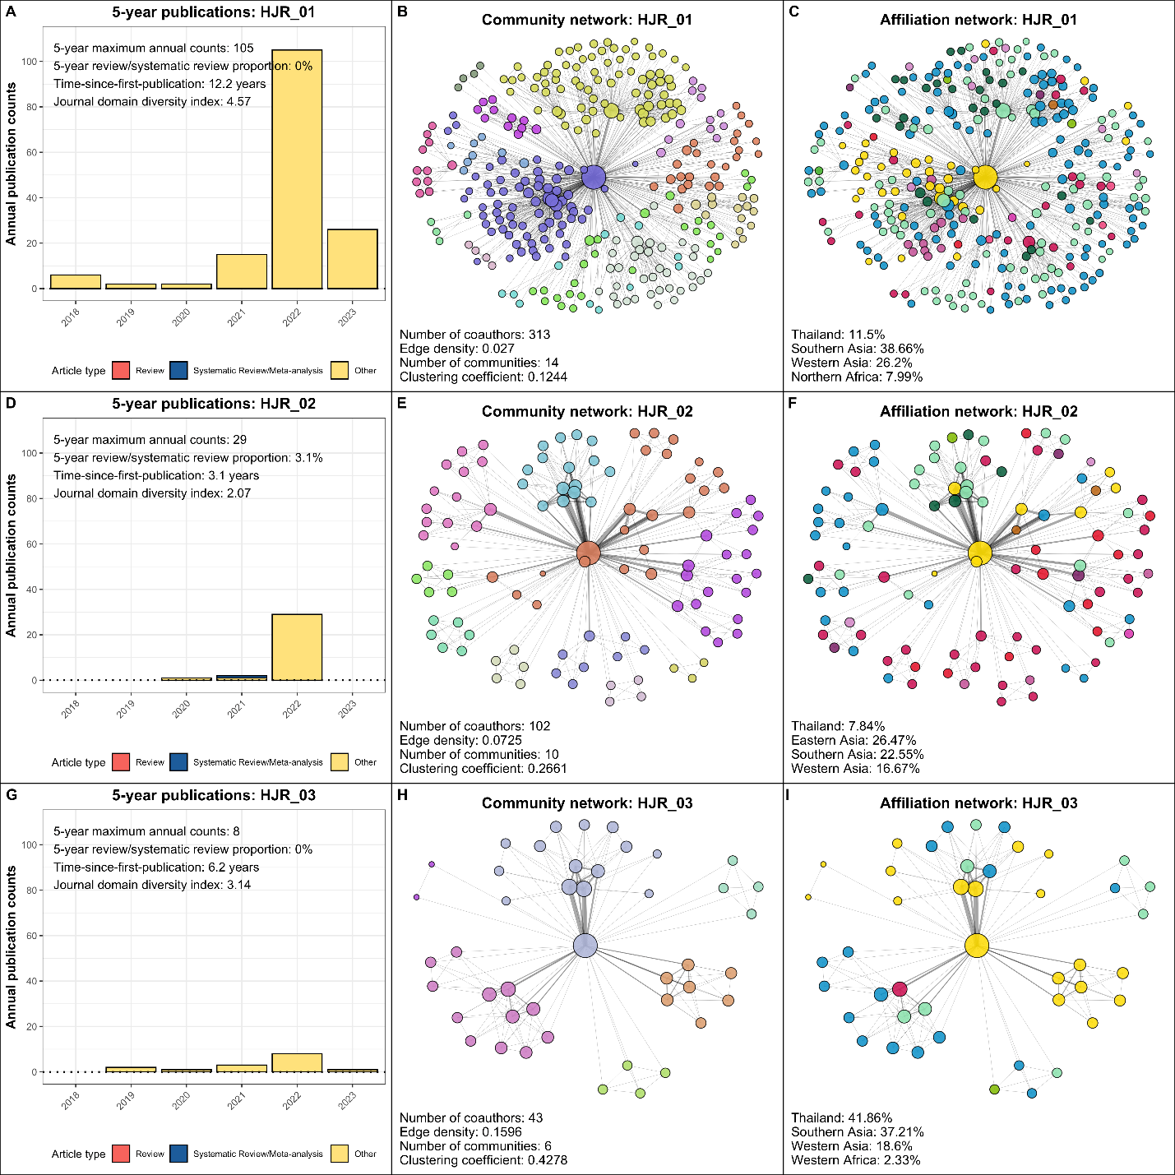

Figure S3 Authorship profiles of high-performance junior researchers HJR_01 (A to C), HJR_02 (D to F), and HJR_03 (G to I). Panels A, D and G: Annual publication counts during recent 5 years (2018 to 2023), highlighted by types of articles (review article, systematic review/meta-analysis articles, or other article types). Panels B, E, and H: Communities within the co-authorship network, indicated by colors. Panels G, H, and I: Geographical subregions of coauthors’ affiliations within the co-authorship network, indicated by colors. Researchers with an affiliation in Thailand are represented by yellow nodes.

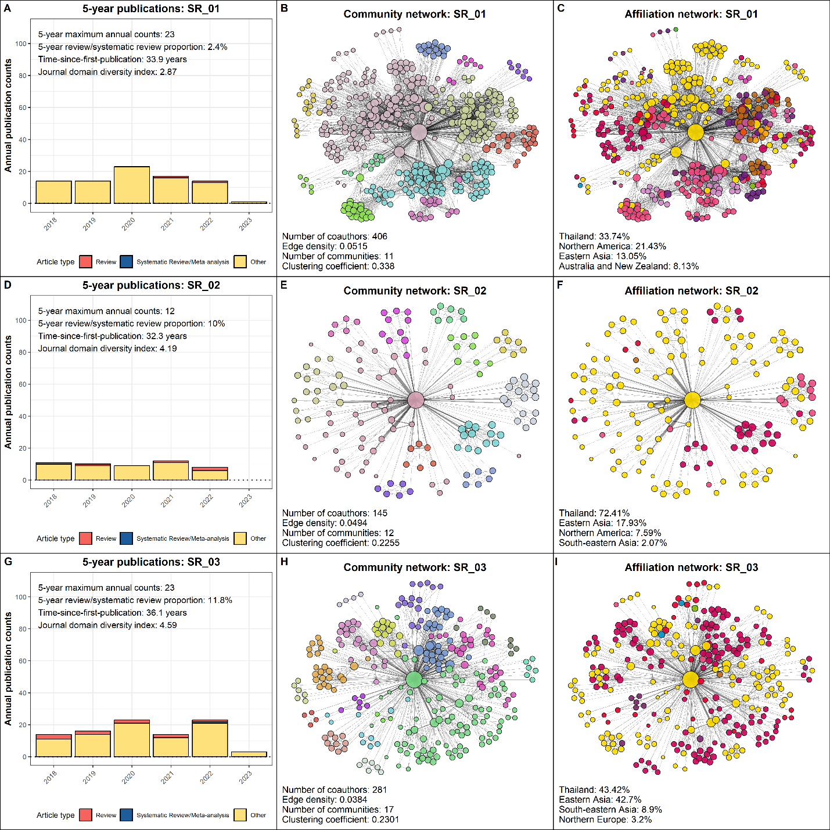

Figure S4 Authorship profiles of senior researchers SR_01 (A to C), SR_02 (D to F), and SR_03 (G to I). Panels A, D and G: Annual publication counts during recent 5 years (2018 to 2023), highlighted by types of articles (review article, systematic review/meta-analysis articles, or other article types). Panels B, E, and H: Communities within the co-authorship network, indicated by colors. Panels G, H, and I: Geographical subregions of coauthors’ affiliations within the co-authorship network, indicated by colors. Researchers with an affiliation in Thailand are represented by yellow nodes.